**Week 2 Lab Assembler**

**Group 65**

**Integrants: 110504517 李睿穎 (Leader)，110504518 鍾秉均 (Member)**

Full Code

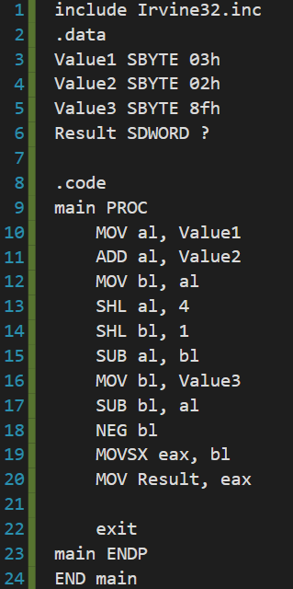

Register & Memory before start

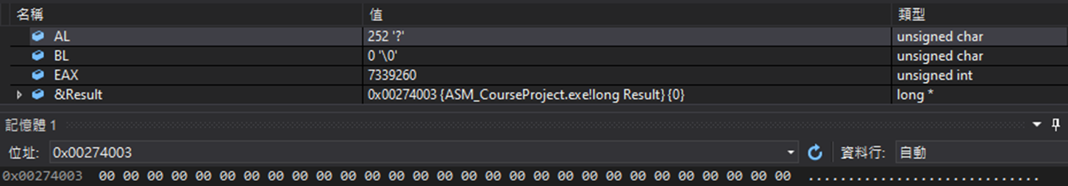

Execution flow

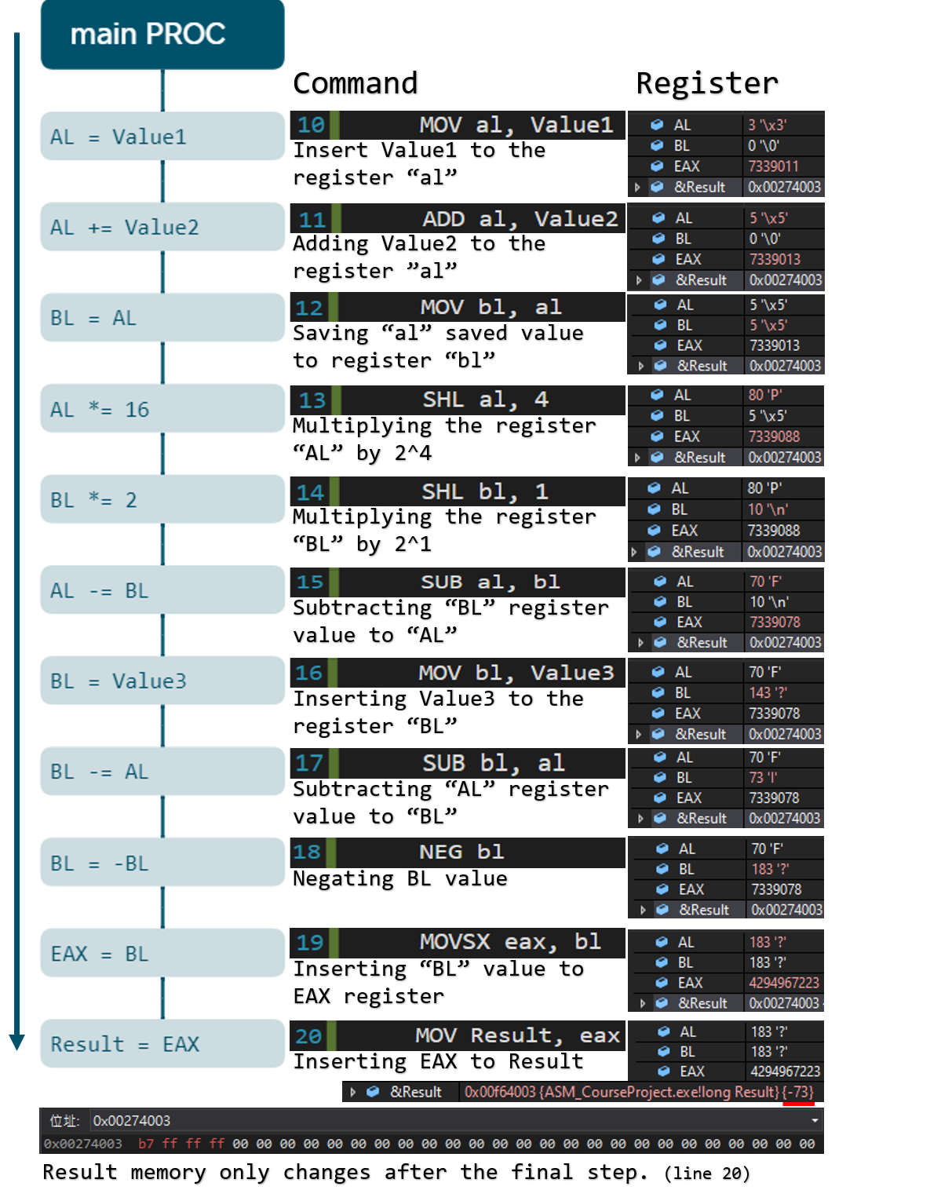

Review for the class

On today’s experiment we learned how to do simple maths calculations on assembler code. We learned how shifting bits may affect the value we are operating on and although this “simple” math equation is a much complicated than coding on other languages other than assembler, it lets us know how the computer calculates this simple math equations by observing how the registers change along the program.